Workshop Handbook
Neha Moopen & Lilli van Wielink
2024-04-26
Table of contents

Welcome
The UB & ITS collaborate on workshops aimed at working with data and software in line with Open Science and FAIR Principles. As our collaboration grows closer within and between workshops, this Handbook is being developed as a common reference that consolidates information on how we develop and organize these workshops.

Before
This section provides an overview of what needs to occur while planning workshops for the upcoming academic year.

Jaarplanning
Before commencing the with the jaarplanning, the department should decide on which workshops will be offered (or not) and who will be involved in the workshop as leads and instructors/helpers. This would likely be decided during the Annual Review.

Workshop Agenda
By the end of May, we should have the jaarplanning for the next academic year ready.
When doing this jaarplanning, we should take the following into account:
- the frequency of the workshop,
- the preferred days for the workshop,
- the number of participants for the workshop,
Moreover, the workshops should be spaced out well, so we don’t have weeks that are too busy or vice versa.
Here is an example of the workshop agenda for 2023-2024: RDM Support -> General -> Training & Workshops -> Workshop Communication Materials -> workshops-planning-2023-2024.xlsx
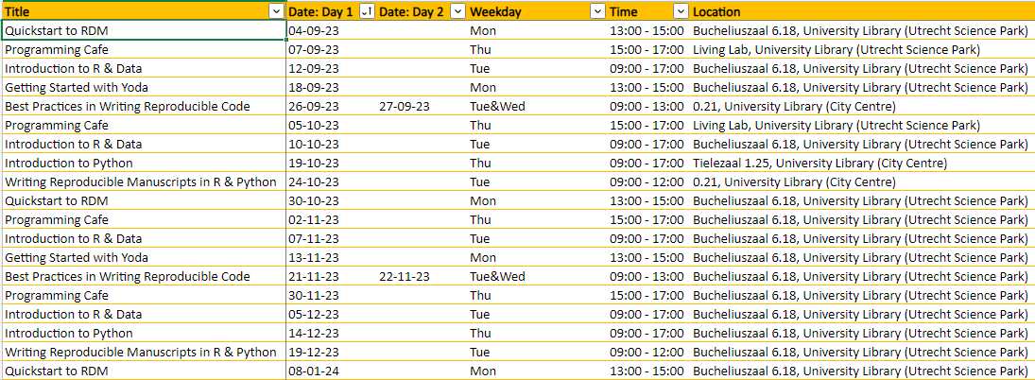

Room Booking
We need to book locations for all the workshops in advance. This can be done via the the booking system or by contacting colleagues in Publieksdiensten (probably not called the same now after the reorganization).

Outlook Calendar
When the jaarplanning is done, put it in an Outlook calendar that can be shared with everyone.
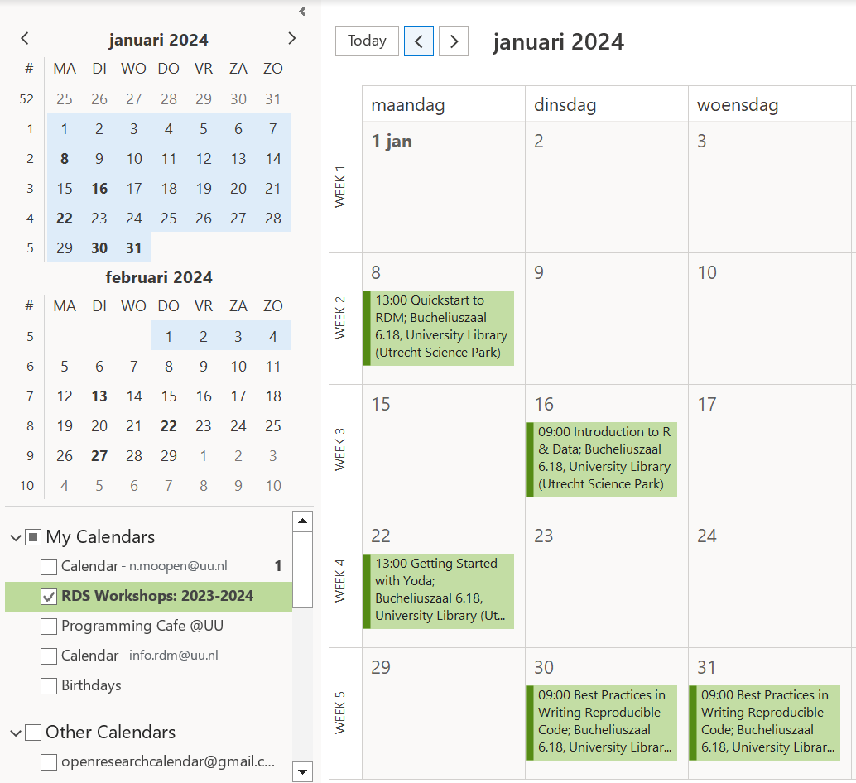
You can use the Excel sheet from the jaarplanning to create calendar items in bulk. Here are two links for reference:
- https://www.techrepublic.com/article/how-to-import-excel-records-into-an-outlook-calendar/
- https://www.auditexcel.co.za/blog/import-excel-appointments-into-outlook-calendar/
After that, you can choose to either share or publish your Outlook calendar:
- https://support.microsoft.com/en-us/office/share-your-calendar-in-outlook-com-0fc1cb48-569d-4d1e-ac20-5a9b3f5e6ff2

Sign Up Sheet
Also make a page where people can sign up or simply report who will be going.
May be redundant with the pool of instructors and helpers but might still help maintain overview. Maybe sign up for the whole academic year / commit to one workshop and then figure it out within your team. To be discussed.
Here is a link to the sign-up sheet for 2023-2024: RDM Support -> Team Code and Software -> Workshops & Cafes (tab)
The Excel sheet can also be used as a basis for creating this sign-up sheet tab, you don’t have to create entries separately.
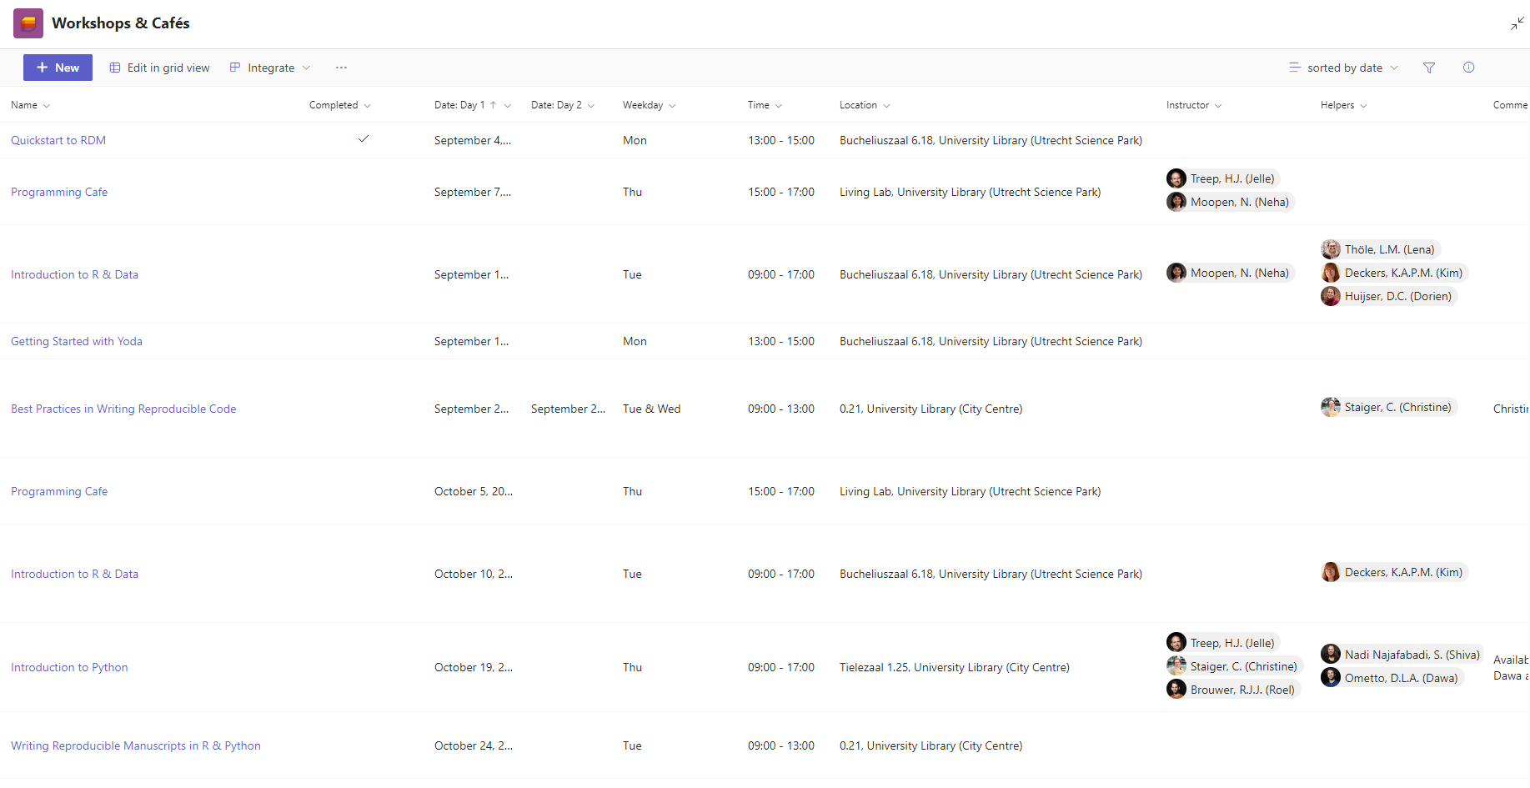

Website
The following folder contains (per workshop) all the texts for landing pages, agenda items, Formdesk forms and confirmations, pre- and post-workshop emails: RDM Support -> General -> Training & Workshops -> Workshop Communication Materials
There is also an Excel sheet to track the review and update of materials:
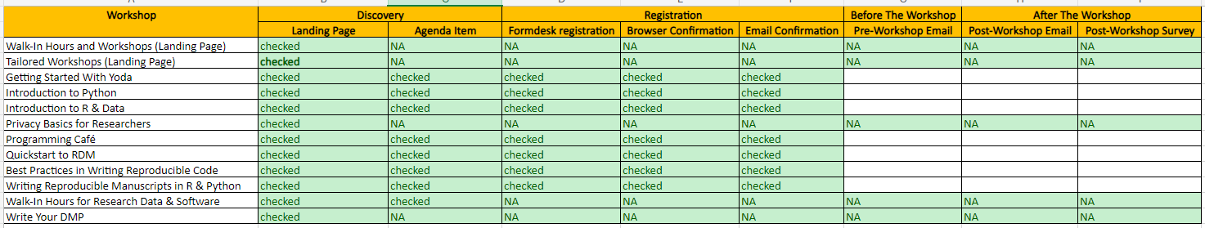
RDM Support -> General -> Training & Workshops -> Workshop Communication Materials -> workshops-planning-2023-2024.xlsx

Landing Page
Review the landing page text for all workshops. Lilli makes template and the workshop leads do the reviewing (primarily of workshop description/content, the more admin stuff will be generic).
Example of landing page for Introduction to R & Data: https://www.uu.nl/en/research/research-data-management/training-workshops/introduction-to-r-data
The landing page is a generic description of the workshop and includes an overview of all workshop dates with link to the specific agenda item.
- prerequisties
- what you can expect (or not)
- UU and UU-affiliated only
- costs
- deregistration and no-show/dropout policy
Note that a Dutch translation will be needed as well.

Agenda Items
The agenda item is specific to a workshop date/occurence and includes the link to the registration form.
Example of agenda item for Introduction to R & Data: https://www.uu.nl/en/events/introduction-to-r-data-may-2024
Note that a Dutch translation will be needed as well.

Formdesk
How to handle waitlists? Maximum number of participants? Maximum number of waitlisted participants?

Formdesk Form
The Formdesk registration form is largely the same for all workshops. There are generic questions related to registration, but a couple of specific questions per workshop.
Make sure that the werkstudenten ensure only UU and UU-affiliated addresses are accepted for registration! Provide a list of these addresses (UMCU, PMC, etc.)
Here is a link to the default questions for Formdesk at the moment: RDM Support -> General -> Training & Workshops -> Workshop Communication Materials -> _formdesk -> default-questions-formdesk-registration.docx

Browser Confirmation
This refers to the text that appears in your browser when the registration is confirmed. It points to info.rdm@uu.nl as contact point in case a confirmation email is not received.
RDM Support -> General -> Training & Workshops -> Workshop Communication Materials -> _formdesk -> default-questions-formdesk-confirmation.docx

Confirmation Email
This refers to the email that participants receive when their registration is confirmed. It points to info.rdm@uu.nl as contact point and includes a personalized link for deregistration.
RDM Support -> General -> Training & Workshops -> Workshop Communication Materials -> _formdesk -> default-questions-formdesk-confirmation.docx
We might want to consider putting the pre-workshop email in the Formdesk confirmation email already?

Werkstudenten
Once all the documents have been reviewed and/or updated, have the Communicatie werkstudenten put everything online. They can be contacted at: werkstudentCC@uu.nl
It can take them up to a month to process everything for a whole academic year. We naturally want to prioritize the workshops from September-December, so people can already start signing up for that.
Some things they should do: number of participants, UU & UU-affiliated addresses, specify the owners and co-owners for the form, notification if it’s registration less than 7 days.
It would be helpful to give them a briefing of instructions like in this document: RDM Support -> General -> Training & Workshops -> Workshop Communication Materials -> briefing-work-students.docx

New
- We need a TIMELINE for the jaarplanning and coordination – when do we wanna schedule big group meetings, review moments, determine leads 🎉
- Create a TASK BOARD for workshops if we think it’s useful.
- List the workshops + e-learnings we want do/maintain next academic year. Determine what to do with stuff that might be phased out (if at all). You might archive it for example.
- Determine the leads of these workshops, as well as a pool of instructors and helpers per workshop. Clarify and agree on what these roles mean and involve (and not).

During
This section provides an overview of what needs to occur during the academic year as we go through the planned workshops.

Communication

Q&A
Any Q&A or communication about the workshops should go through TopDesk. The workshop leads are responsible for picking up calls related to their respective workshops. Any other calls can be picked by the workshop coordinator or the team member monitoring TopDesk that day, depending on what is required.

Waitlists
Currently, requests to be waitlisted for workshops are directed to TopDesk. The workshop lead should:
- place the call under their name
- set the due date to one week before the workshop
- send a response acknowledging the waitlist request (TODO: make a template)

Pre-Workshop

Pre-Workshop Email
The pre-workshop email should be sent out one week before the workshop is to take place. The email should be placed within an Outlook appointment. The workshop lead has primary responsibility for this.
The following folder contains (per workshop) all the texts for pre- and post-workshop emails: RDM Support -> General -> Training & Workshops -> Workshop Communication Materials
TODO: review pre-workshop email in general, but also include deregistration reminder and no-show/dropout policy.

Catering
We are currently arranging tea and coffee ourselves. If a budget for catering is arranged, the workshop lead will need to book the catering at least >=3 days before the workshop is to take place.

Workshop
During the workshop, we distinguish between Instructors and Helpers in terms of our role for that day. The Instructor is responsible for teaching: they are at the front of the room and go through the slides and demos. The Helper is responsible for walking around the room and supporting participants during the workshop, especially during the exercises. These are not fixed roles, we expect colleagues will take turns with a different role every time a workshop takes place. For those who are new to the workshop, it may be helpful to be a Helper for a couple of rounds before picking up the Instructor role.
It’s helpful if at least 2 colleagues arrive earlier to open the room and help set up the space.
We also want to take attendance during the workshop to keep our numbers up to date: registrants, deregistrants, attendees, no-shows.
Start the workshop with a round of introductions. End the workshop with necessary closing information.
After the workshop, it may be helpful to have an informal discussion on how the workshop went. Feedback can be exchanged and questions can be answered. If there are action points, the workshop lead can pick them up or make GitHub Issues if needed.

Post-Workshop

Post-Workshop Email
The post-workshop email should be sent out as soon as possible after the workshop, ideally the very next day but not later than 1 week after the workshop. The workshop lead has primary responsibility for this.
The following folder contains (per workshop) all the texts for pre- and post-workshop emails: RDM Support -> General -> Training & Workshops -> Workshop Communication Materials
TODO: The workshop lead should update the Excel sheet tracking workshop-related numbers, i.e. registrants, deregistrants, attendees, no-shows.

Quarterly Review

Pizza Party
The workshop coordinator will organize a Quarterly Review, hopefully with pizza to discuss how things are going.

Post-Workshop Survey
The post-workshop email contains a link to the post-workshop survey. The survey is hosted on Qualtrics and a report can be derived on a quarterly and annual basis to evaluate workshop-related feedback from participants.

After
This section provides an overview of what needs to occur towards the end of the academic year, as we get closer to wrapping up all the workshops.
The ‘timing’ of activities in this section will overlap with those associated with planning for the upcoming academic year, but they serve different purposes.

Annual Review
During the Annual Review, we reflect on the year as a whole and what we might want to do differently in the upcoming year. In addition to evaluating the pre- and post-workshop surveys and our experiences in general. The following decisions can be made:
- which workshops will be provided the next year
- who will comprise the sub-team for each workshop
- who will be the workshop lead
- what are the action points and to-dos that need to be carried our as part of the jaarplanning
- what is the planning/timeline towards implementing the action points
- what is needed from everyone to develop themselves and have a good time teaching the workshops

Workshop Materials

Maintenance
After the last workshop has taken place, all associated materials should be archived on Zenodo.
- Workshops related to data are typically PowerPoint presentations. These should be uploaded to Zenodo, along with a pdf copy.
- Workshops related to software have materials built with Quarto and hosted on the Utrecht University GitHub organization. The repositories on GitHub should be integrated with Zenodo first and a ‘release’ of the repository should be made on an annual basis. Zenodo will detect the release and automatically archive it.

Development
Teams for each workshop are encouraged to get together and work on updating / developing the materials further. If colleagues switch between workshops to one that the are not familiar with or if we have new colleagues, this can be opportunity to get started with the workshop ‘onboarding’ process until the first workshop actually takes place.

Custom Workshops
- We currently have a small paragraph for custom workshops at: https://www.uu.nl/en/research/research-data-management/workshops
- TODO: a separate landing page for the custom workshops with a gallery/portfolio (links to Zenodo or GitHub) showing examples of custom workshops we have done?
- Requests for custom workshops should be directed to the workshop coordinator via TopDesk.
- The workshop coordinator will bring the request to the team and we will decide if we can do it and who will do it.
- If the workshop can be carried out, the workshop coordinator will link the contactperson with the colleagues who are picking it up. They will also check with the contactperson about how they found out about us and our offering.
- If possible, the post-workshop survey should be distributed to the attendees.
- After the workshop, the colleagues will report back to the workshop coordinator with the number of attendees.
- The colleagues will FAIRify the workshop materials on Zenodo and provide the link to the workshop coordinator.
- The workshop coordinator will update an Excel sheet with the following information:
  - The name of the workshop
  - The contactperson (name, email, faculty, position)
  - How the contactperson found out about us and our offering
  - The names of colleagues who gave the workshop
  - The number of attendees
  - The link to the FAIRified workshop materials

E-Learnings
- Learn to Write Your DMP
- Privacy Basics For Researchers

New
- We need a TIMELINE for the jaarplanning and coordination – when do we wanna schedule big group meetings, review moments, determine leads 🎉
- Create a TASK BOARD for workshops if we think it’s useful.
- List the workshops + e-learnings we want do/maintain next academic year. Determine what to do with stuff that might be phased out (if at all). You might archive it for example.
- Determine the leads of these workshops, as well as a pool of instructors and helpers per workshop. Clarify and agree on what these roles mean and involve (and not).
- Do a jaarplanning where all the workshops are spread out evenly, at a frequency that suits everyone and on preferred days.
- Book locations for the workshops.
- Create an Outlook calendar for the workshops and share it with everyone.
- Create a sign up sheet where people can add themselves as instructors and helpers. May be redundant with the pool of instructors and helpers but might still help maintain overview. Maybe sign up for the whole academic year / commit to one workshop and then figure it out within your team. To be discussed.
- Review the landing page text -> Lilli makes template and leads do the reviewing (primarily of workshop description/content, the more admin stuff will be generic)
- Review the agenda item text. -> see above
- Review the formdesk registration form / LOBBY FOR LIBCAL OR SOMETHING BETTER / LIMIT registrations based on email
- Review the formdesk browser confirmation and confirmation email.
- NEW: consider putting the pre-workshop email in the formdesk confirmation already???
- Have the werkstudenten put everything online.
- DOUBLE-CHECK: make sure only UU and UU-affiliated addresses are accepted
- REVIEW: HOW TO HANDLE WAITLISTS??? Max number of participants? Max waitlists?
- Review templates for pre-workshop emails -> provide a template and review
- NEW: consider sending outlook appointment with pre-workshop email?
- NEW: no-show and drop-out policy
- NEW: Propose catering budget for coffee and tea - > LEAD should book the actual catering
- Review templates for post-workshop emails
- NEW: finish automating survey report (Formdesk + Qualtrics combi)
- NEW: plan quarterly/biannual evaluation moment
- NEW: update all workshop materials to Quarto website instead of book?
- NEW: provide template and instructions for Quarto website.
- NEW: how to align non C&S workshops for similar look and feel? I would say make single page website with the slides embedded..
- Dobule-check repos for integration with Zenodo for DOI
- NEW: align ongoing workshops with less visible workshops like VRE and HPC etc. Anything from ITS
- NEW: make a workshop portfolio page including data stuff, software stuff, UB, ITS, e–modules…separate section for links to custom workshops in the past -> talk to ML
- NEW: decision making process for starting new (standard) workshops, ending ongoing workshops, timeline, materials
- NEW: decision making process for providing custom workshops -> also admin like number of requests, attendees etc.
- NEW: one off workshops for the joy of it before making it standard (summer school / winter school for example)
- NEW: decision making process for e-module development and maintenance
- NEW: formdesk vs. LibCal?

